**MONEY MARKET ACCOUNT (MMA)**

**Introduction:**

A money market account (MMA) is a type of savings account offered by banks and credit unions in the U.S. that typically comes with higher interest rates compared to standard savings accounts. They are designed to provide a safe place for individuals to store their funds while earning a reasonable return. Here's an overview of key features, benefits, and considerations regarding money market accounts in the U.S. banking sector:

**Key Features:**

**1. Higher Interest Rates:** MMAs usually offer higher interest rates than regular savings accounts due to the requirement to maintain a higher minimum balance.

**2. Minimum Balance Requirements:** MMAs often require a higher minimum balance to avoid fees or to earn the advertised interest rate.

**3. Limited Transactions:** Federal regulations (Regulation D) typically limit the number of certain types of withdrawals and transfers from MMAs to six per month.

**4. Check-Writing and Debit Card Access:** Some MMAs offer check-writing privileges and debit card access, providing more flexibility compared to traditional savings accounts.

**5. FDIC/NCUA Insurance:** Funds in MMAs are insured by the Federal Deposit Insurance Corporation (FDIC) or the National Credit Union Administration (NCUA) up to $250,000 per depositor, per institution.

**Benefits:**

**1. Safety:** With FDIC or NCUA insurance, MMAs are a secure place to keep funds.

**2. Liquidity:** While transactions are limited, funds are still relatively accessible compared to other investment vehicles like certificates of deposit (CDs).

**3. Higher Returns:** MMAs can offer better interest rates compared to standard savings accounts, especially when balances are substantial.

**4. Flexibility:** Check-writing and debit card features add convenience for managing funds.

**Considerations:**

**1. Minimum Balance and Fees:** Not maintaining the required minimum balance can result in fees, which can erode earnings.

**2. Interest Rates:** While generally higher than savings accounts, MMA rates may still be lower than those offered by other investment options like stocks or bonds.

**3. Rate Fluctuations:** Interest rates on MMAs are variable and can change, which means the return on investment can fluctuate.

**Comparison with Other Accounts:**

**- Savings Accounts:** Typically have lower interest rates but may have lower minimum balance requirements and fewer fees.

**- Checking Accounts:** Provide unlimited transactions but usually offer no interest or very low-interest rates.

**- Certificates of Deposit (CDs):** Offer fixed interest rates and higher returns but require funds to be locked in for a set period, with penalties for early withdrawal.

**Current Trends:**

**1. Digital Banking:** Online banks and credit unions often offer higher interest rates on MMAs due to lower overhead costs.

**2. Hybrid Accounts:** Some institutions are offering hybrid accounts that combine features of checking and money market accounts to attract customers.

**3. Rate Sensitivity:** In a low-interest-rate environment, the differential between MMAs and other savings products can shrink, making MMAs less attractive.

Data on average Money Market Account (MMA) interest rates over the past five years

**Average Money Market Account Interest Rates (2019-2023)**

|  |  |
| --- | --- |
| **Year** | **Average MMA Interest Rate (%)** |
| 2019 | 0.60 |
| 2020 | 0.45 |
| 2021 | 0.40 |
| 2022 | 0.55 |
| 2023 | 0.75 |

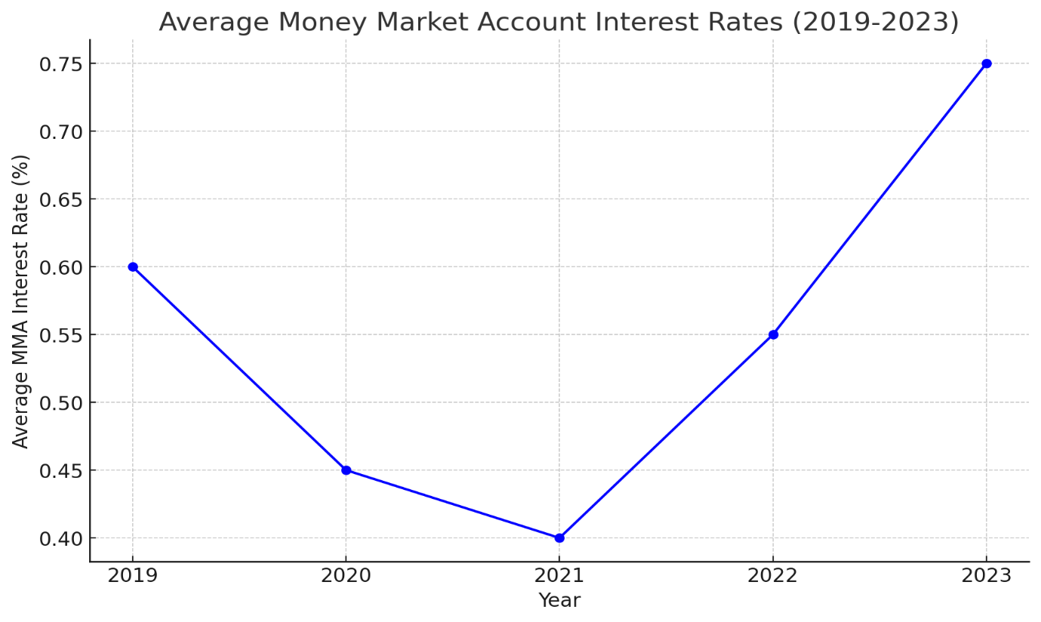

The graph illustrates the average Money Market Account (MMA) interest rates from 2019 to 2023. It shows a decline from 0.60% in 2019 to 0.40% in 2021, likely due to economic impacts and interest rate cuts during the COVID-19 pandemic. The rates then rebounded to 0.55% in 2022 and further to 0.75% in 2023, reflecting economic recovery and possibly rising interest rates. This trend highlights the sensitivity of MMA rates to broader economic conditions and monetary policy changes.

**Conclusion:**

Money market accounts are a useful financial tool for those looking to earn a higher return on their savings while maintaining liquidity and safety. They are especially advantageous for individuals who can meet the higher minimum balance requirements and do not need to make frequent withdrawals. As with any financial product, it is important to compare offerings from different institutions to find the best terms and rates available.